Objective Questions
- What is the distribution of account balances across different regions?
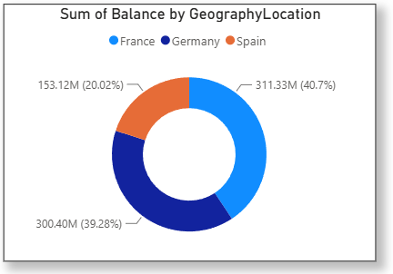
Answer:
Approach:
There are currently three regions in the dataset: France, Germany, and Spain.
To determine the distribution of account balances, we calculate the total balances and group them by the regions (Geography).
Insight:
From this donut chart that we used to visualize the distribution of balances across different regions, we draw an insight that France has the highest account balance.

- Identify the top 5 customers with the highest Estimated Salary in the last quarter of the year. (SQL)
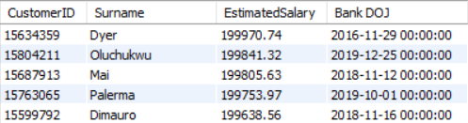
Answer:

Approach:

Firstly, I filter the records with QUARTER(`Bank DOJ`) = 4, so that I will get only last quarter, i.e., Quarter 4 for the years present in the data.

Then to identify the top 5 customers with the highest estimated salary, we sort the data in descending order of Estimated Salary and then limit our selection to the top 5 records.

- Calculate the average number of products used by customers who have a credit card. (SQL)
Answer:
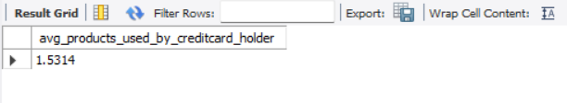
Approach:

The average number of products used by customers who have a credit card is 1.5314
To determine this, we calculate the average of `NumOfProducts` for customers who have a credit card after filtering the data accordingly.

- Determine the churn rate by gender for the most recent year in the dataset. (SQL)
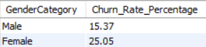
Answer:
Approach:
To determine this, firstly we filter the data to only get the records of the most recent year in the dataset which is 2019, then we calculate the churn rate by gender.

- Compare the average credit score of customers who have exited and those who remain. (SQL)
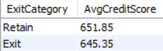
Answer:
Approach:
To achieve this, we calculate the average credit score of customers grouped by their exit status.

- Which gender has a higher average estimated salary, and how does it relate to the number of active accounts? (SQL)
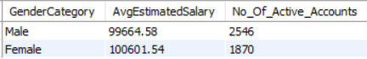
Answer:
Insight:
- Female has the higher average estimated salary than that of Male.
- Male has the higher number of Active accounts than that of Female.
- Segment the customers based on their credit score and identify the segment with the highest exit rate. (SQL)
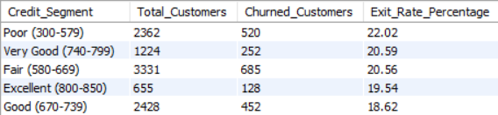
Answer:
Insight:
Customers with a credit score between 300 and 579 are in Poor credit segment category, and have the highest churned/exit rate percentage (22.02 %).
- Find out which geographic region has the highest number of active customers with a tenure greater than 5 years. (SQL)
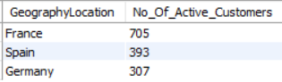
Answer:
Insight:
Clearly, France has the highest number of active customers with a tenure greater than 5 years.
- What is the impact of having a credit card on customer churn, based on the available data?
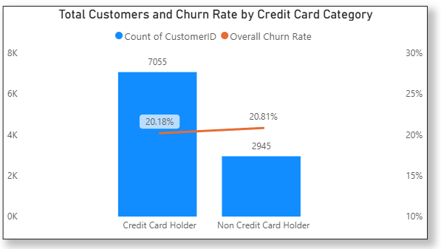
Answer:
Insight:
Based on the data, there is almost no impact of having a credit card as there is very marginal churn rate difference between credit card holders (20.18%) and non-credit card holders (20.81%).
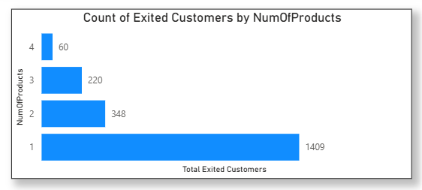
- For customers who have exited, what is the most common number of products they have used?
Answer:
Approach:
To determine the most common number of products used by exited customers, we analyse the dataset focusing on customers who have exited. We count the occurrences of each number of products used and identify the number that appears most frequently among these exited customers.
Insight:
The bar chart clearly indicates that the most frequent number of products used by churned or exited customers is 1, with 1,409 out of the total number of churned or exited customers falling into this category.

- Examine the trend of customers joining over time and identify any seasonal patterns (yearly or monthly). Prepare the data through SQL and then visualize it.
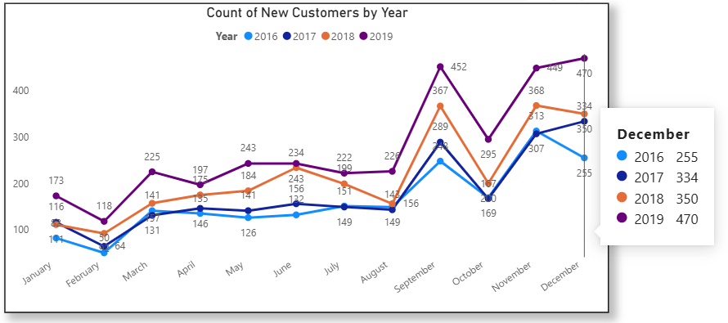
Answer:
Insight:
From the above Line chart, we can say that:
- March, September and November: Spike in new customers joining every year.
- February and October: Downfall in new customers joining every year.
- Analyse the relationship between the number of products and the account balance for customers who have exited.
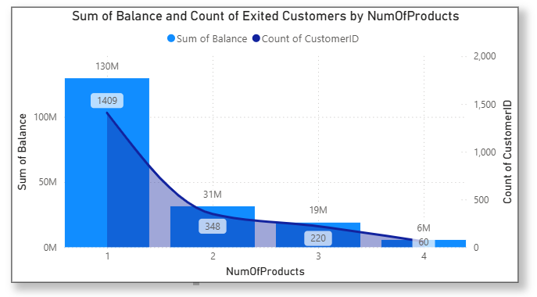
Answer:
Insight:
The relationship between the number of products and account balance shows that the total balance and count of exited customers decreases as the number of products increases. This suggests that more customers tend to use fewer products. The analysis used the total balance instead of the average balance because the average balance is similar across all segments, and number of customers in each product segment is different.
- Identify any potential outliers in terms of balance among customers who have remained with the bank.
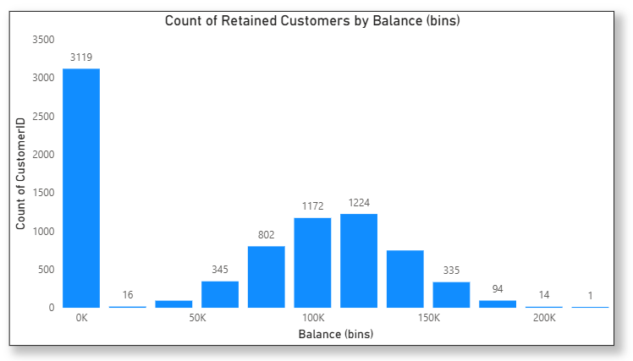
Answer:
Insight: Among the retained customers, it is found that the majority of customers (3119) have balance less than 20k and also most of them has 0 balance in their respective accounts.
- How many different tables are given in the dataset, out of these tables which table only consists of categorical variables?
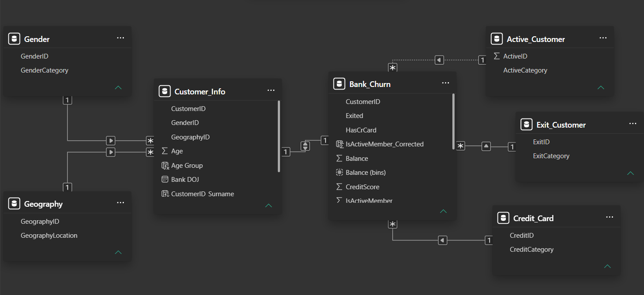
Answer:

Insight:

There were 7 different tables given in the dataset, and out of these, 5 tables contain only categorical variables which are: Gender, Geography, Active_Customer, Exit_Customer, Credit_Card.

- Using SQL, write a query to find out the gender-wise average income of males and females in each geography id. Also, rank the gender according to the average value. (SQL)
Answer:
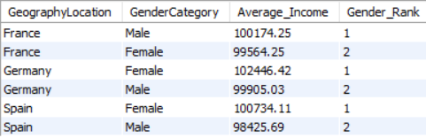

Approach:

- Calculate Average Income by Gender and Geography: Use SQL to group customers by `Geography` and `Gender`, calculating the rounded average of Estimated Salary for each group.

- Rank Gender by Average Income: Utilize the RANK() window function to rank genders within each `Geography` based on their average income, ordering results by `Geography` and the ‘Gender Rank’.

- Using SQL, write a query to find out the average tenure of the people who have exited in each age bracket. (18-30, 31-50, 50+)
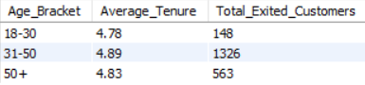
Answer:
Approach:
- Categorize Age Groups: Use SQL to classify customers into age brackets (18-30, 31-50, 50+) based on their `Age`.

- Calculate Average Tenure: Calculate the rounded average `Tenure` of customers who have exited (`Exited = 1`) within each age group.

- Group and Order Results: Group the results by age bracket and order them accordingly to display the average tenure for each category.
- Is there any direct correlation between salary and the balance of the customers? And is it different for people who have exited or not?
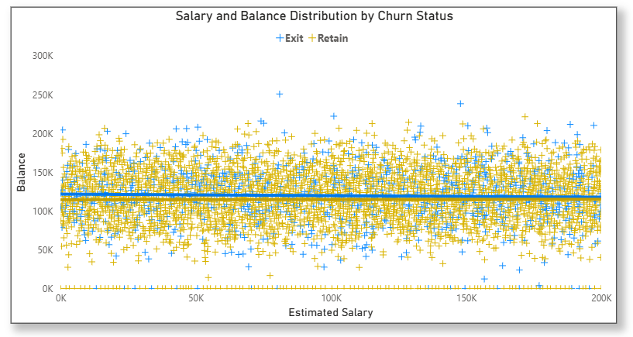
Answer:

Correlation Analysis:

Those almost perfectly flat trendlines confirm exactly that: there is absolutely zero correlation between a customer's salary and their account balance, regardless of whether they stay or leave.
- Is there any correlation between the salary and the Credit score of customers?
Answer:
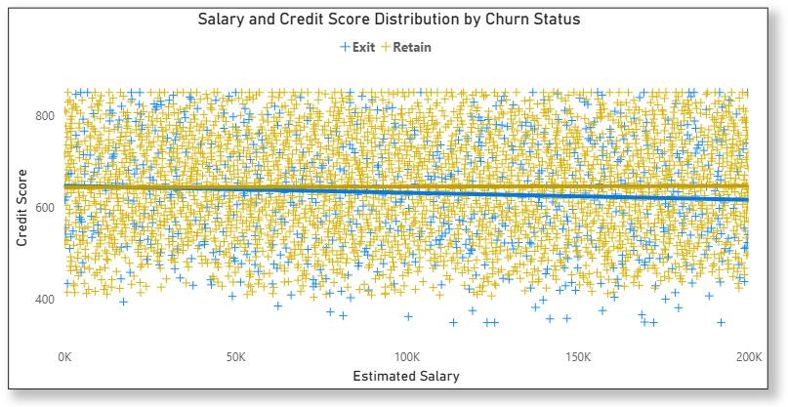
Correlation Analysis:

The dots are scattered entirely at random from top to bottom and left to right. This visually confirms a correlation score of practically zero.

- The Retained Line (Yellow): This line is perfectly horizontal. For loyal customers, salary and credit score have absolutely zero impact on one another.

- The Exited Line (Blue): The blue line tilts slightly downward. This indicates a very weak negative correlation. It suggests that among the customers who left the bank, those with higher salaries tended to have slightly lower credit scores.

- Rank each bucket of credit score as per the number of customers who have churned the bank. (SQL)
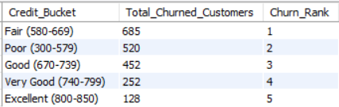
Answer:
Insight:
- "Fair (580-669)" credit scores bucket actually experience the highest volume of churn simply because the majority of the general population falls into those brackets.

- “Excellent (800-850)” credit scores bucket experience the lowest volume of churn simply because very few of the customers fall into those brackets.

- According to the age buckets find the number of customers who have a credit card. Also retrieve those buckets that have lesser than average number of credit cards per bucket. (SQL)
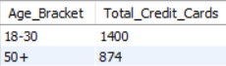
Answer:

Approach:

- Age Bucket Calculation: Group customers into age categories (e.g., 18-30, 31-50, 50+).

- Count Customers with Credit Cards: Use SQL to count customers with credit cards in each age bucket.

- Compute Average Credit Cards: Calculate the average number of credit cards per age bucket.

- Identify Below-Average Buckets: Retrieve age buckets where the number of credit cards is less than the average.
- Rank the Locations as per the number of people who have churned the bank and average balance of the customers. (SQL)
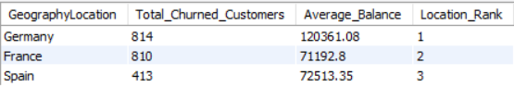
Answer:
Insight:
Germany has the highest exited customers, as well as the highest average balance of those exited customers.
- As we can see that the “CustomerInfo” table has the CustomerID and Surname, now if we have to join it with a table where the primary key is also a combination of CustomerID and Surname, come up with a column where the format is “CustomerID_Surname”.
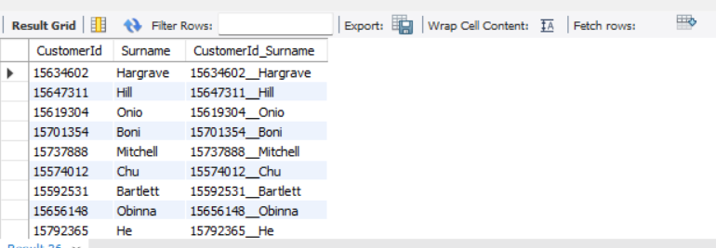
Answer:

- Without using “Join”, can we get the “ExitCategory” from ExitCustomers table to Bank_Churn table? If yes do this using SQL.
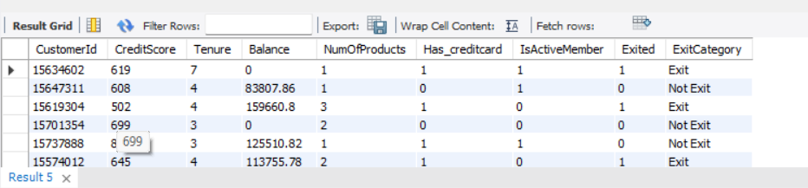
Answer:

Approach:

The correlated subquery:

SELECT b.*,
(
SELECT e.ExitCategory
FROM exit_customer e
WHERE b.Exited = e.ExitID
) AS ExitCategory
FROM bank_churn b;

This approach avoids using a traditional JOIN operation and directly fetches the ExitCategory, using a correlated subquery within the SELECT statement.
- Were there any missing values in the data, using which tool did you replace them and what are the ways to handle them?
Answer:
Fortunately, our current dataset has no missing values, sparing us from the complications of dealing with them and avoiding potential biases introduced by imputation techniques.

Handling Missing Values: A Reference for Future Analysis
While we do not face the problem of missing values in this dataset, it's useful to know the common strategies for managing them in future analyses:
- Deletion: This method involves removing rows or columns that contain missing values. It is suitable when the amount of missing data is negligible and its removal does not significantly affect the analysis. However, it comes with the drawback of losing some information.
- Imputation: This approach fills in missing values with estimated ones. Techniques include imputing with the mean, median, or mode, using k-Nearest Neighbours (KNN), or applying more advanced methods. The choice of method should align with the data type and its distribution characteristics.
- Modelling Techniques: Certain statistical models are capable of handling missing values inherently. Nonetheless, it's crucial to understand why data is missing, as this can influence the appropriate handling method.

- Write the query to get the customer IDs, their last name, and whether they are active or not for the customers whose surname ends with “on”. (SQL)
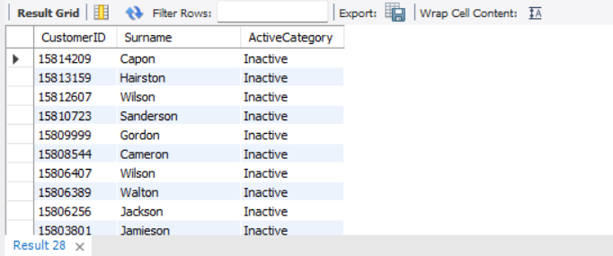
Answer:
SQL query:
SELECT c.CustomerID, Surname, ActiveCategory
FROM customer_info c
JOIN bank_churn b ON c.CustomerID = b.CustomerID
JOIN active_customer a ON a.ActiveID = b.IsActiveMember_Corrected
WHERE Surname LIKE '%on';
- Can you observe any data discrepancy in the Customer’s data? As a hint it’s present in the IsActiveMember and Exited columns. One more point to consider is that the data in the Exited Column is absolutely correct and accurate.
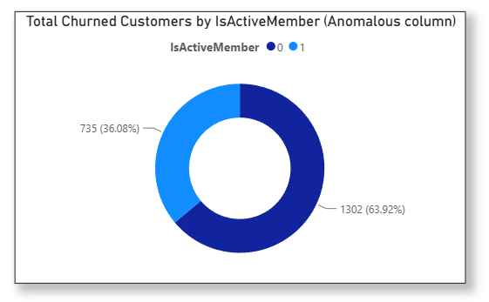
Answer:
Customers who've left the bank should no longer be considered active members.
However, our graph shows that 735 of these exited customers are still marked as "Active Members."
All churned customers should be Inactive.
So, I have created a new column named IsActiveMember_Corrected, where all the churned/exited customers are marked as Inactive.

Subjective Question

- Customer Behaviour Analysis: What patterns can be observed in the spending habits of long-term customers compared to new customers, and what might these patterns suggest about customer loyalty?

Answer:

Looking at the data, we found that customers who have been with us for 4 years tend to spend more. Interestingly, those with a tenure of 5 years show a higher rate of leaving, suggesting they're more likely to churn. Overall, it appears that customer loyalty increases with tenure, meaning those who have been with us longer tend to stick around more.

Approach:

Analyse spending data to identify trends in long-term versus new customer behaviour, noting higher spending among long-term customers. Investigate churn rates at different tenures to understand and address loyalty dynamics.
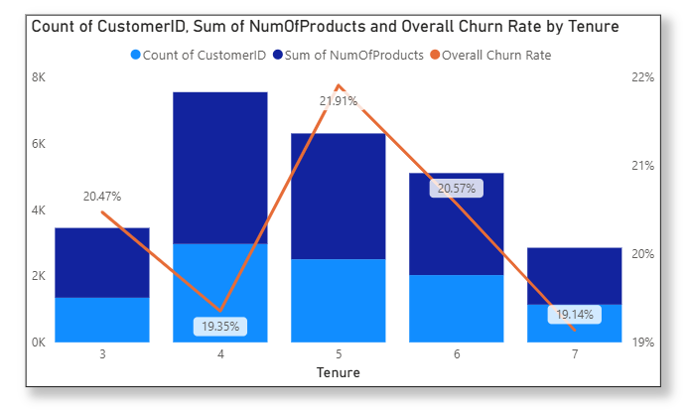

- Product Affinity Study: Which bank products or services are most commonly used together, and how might this influence cross-selling strategies?
Answer:

The data shows that customers with fewer products tend to have a lower churn rate compared to those who have purchased more products.

Approach:

Identify commonly paired products and services to uncover usage patterns, noting that fewer product holdings correlate with lower churn rates. Use these insights to refine cross-selling strategies to enhance customer retention.
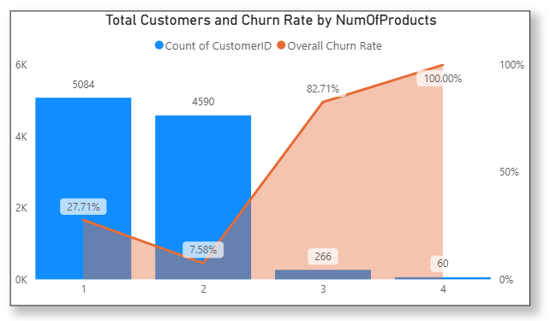
- Geographic Market Trends: How do economic indicators in different geographic regions correlate with the number of active accounts and customer churn rates?

Answer:

From the above visual we can easily get to know that the France has high number of active members as compare to other two locations but churn rate of Germany is high.

Approach:

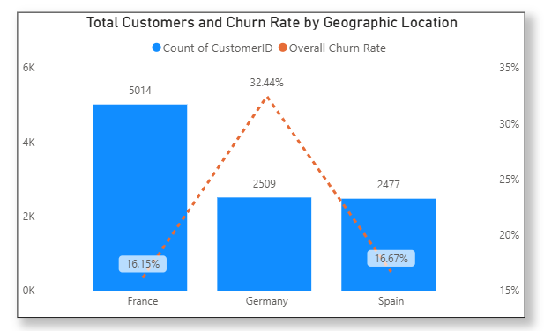
Analyse economic indicators by region to correlate with active account numbers and churn rates, highlighting France's high membership and Germany's high churn. Utilize these findings to tailor regional strategies for retention and growth.

- Risk Management Assessment: Based on customer profiles, which demographic segments appear to pose the highest financial risk to the bank, and why?

Insight:

Highest churn (44.65%) among Aged Adults (50+). Middle Aged Adults (31-50) churn at a moderate rate (19.58%). Customer loyalty is strong among Young Age (18-30) with churn rate around 7.52%.
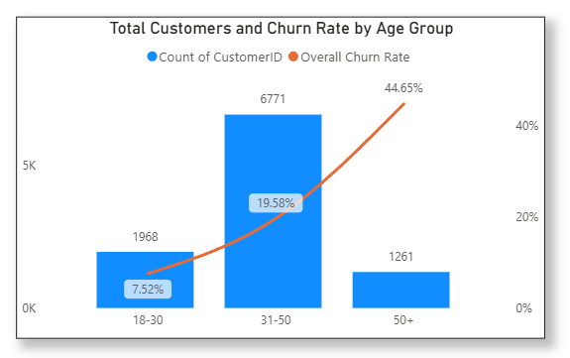
Recommendations:

Target Aged Adults (50+) with incentives and improved service. Focus on increasing customer satisfaction for these age groups.

Leverage CRM to understand their needs and personalize your strategy.

- Customer Tenure Value Forecast: How would you use the available data to model and predict the lifetime (tenure) value in the bank of different customer segments?

Answer:

To accurately forecast the lifetime value of different customer segments using the available dataset, I would follow a structured predictive modelling approach:

- Value Proxy Creation: Estimate an annual revenue metric for each customer by calculating the potential net interest margin on their Balance and factoring in transactional value from their HasCrCard and IsActiveMember status.

- Customer Segmentation: Group the customer base into distinct profiles by combining demographic data (Age, Geography) with financial behaviour (NumOfProducts, Balance tiers).

- Historical Baseline Calculation: Analyse churned customers (Exited = 1) by multiplying their estimated annual value by their actual Tenure to determine the historical profitability of each segment.

- Predictive Modelling: Deploy machine learning algorithms (like Survival Analysis or Random Forest Regressors) trained on historical churn data to forecast the expected remaining tenure of current active customers.

- Lifetime Value (LTV) Forecasting: Multiply the predicted future tenure of active customers by their estimated annual value to project total future profitability, allowing the business to target retention and loyalty programs effectively.

- Marketing Campaign Effectiveness: How could you assess the impact of marketing campaigns on customer retention and acquisition within the dataset? What extra information would you need to solve this?

Answer:

To evaluate how marketing campaigns affect customer retention and acquisition, we need to consider several key strategies and additional data points:

Enhanced Customer Service: Improve customer service by offering personalized assistance, resolving issues quickly, and addressing customer feedback efficiently.

Targeted Offers: The marketing team should create special offers and provide additional security features for customers over the age of 50, as well as offer incentives to customers who purchase multiple products. Special promotions for credit card holders should also be considered.

Customer Segmentation: Group customers by age, location, and the number of products they use. This segmentation allows for a more focused analysis of how different campaigns perform within specific groups.

Trend Analysis: Study changes in active customer numbers, exit rates, and product usage over time. This helps identify trends that might be influenced by marketing efforts.

Control Groups: If possible, establish control groups that haven't been exposed to certain campaigns. Comparing these groups to those that have been exposed can help determine the true impact of the campaigns.

Campaign Details & Timing: Detailed information about campaign content, channels used (e.g., online, offline), and launch dates. This data is essential for linking campaign exposure to changes in customer behaviour.

Customer Acquisition Channel: Information on how customers were originally acquired (e.g., referral, online advertisement). This helps assess whether campaigns are effective in retaining customers acquired through different channels.

Customer Lifetime Value (CLV): Calculate the CLV to understand the long-term impact of marketing campaigns on customer retention and revenue.

- Customer Exit Reasons Exploration: Can you identify common characteristics or trends among customers who have exited that could explain their reasons for leaving?

Answer:

Some common characteristics or trends among customers who have exited that could be the reason for leaving are as follows:

- Demographic Vulnerability: Customers over the age of 50 exhibit higher exit rates, suggesting potential dissatisfaction with the bank's terminology, product offerings, or schemes.

- Financial Profile Risk: A distinct trend of attrition exists among customers holding credit scores below 700.

- Geographic Hotspots: Specific regional markets, notably Germany, demonstrate disproportionately high customer churn rates compared to other locations.

- Service & Experience: Poor overall customer satisfaction is a primary driver of churn, with departures heavily influenced by subpar customer service, prolonged wait times, and unresolved issues.

- Is 'Tenure', 'NumOfProducts', 'IsActiveMember', and 'EstimatedSalary' important for predicting if a customer will leave the bank?

Answer:

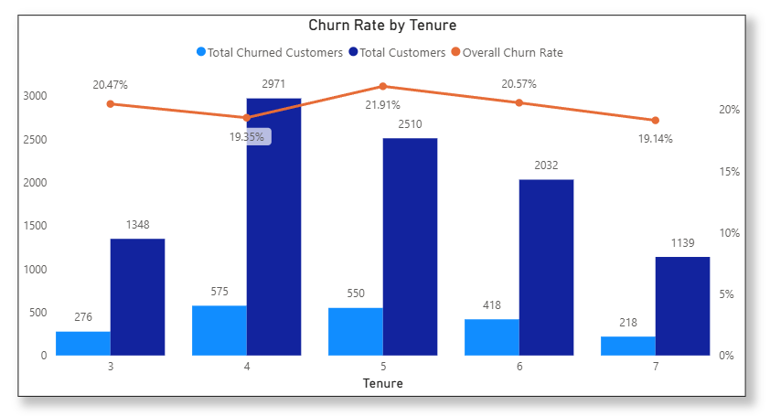
Tenure: This is highly useful for identifying risk windows. Customers with a low tenure (0-1 years) are in the testing phase and are highly volatile. Customers with high tenure have established trust and predictable, low-churn habits. (19% to 22% only)

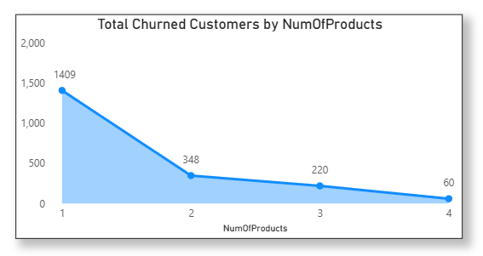
NumOfProducts: This directly measures structural loyalty. Customers with only 1 product (like a basic checking account) have zero switching costs and a high churn rate. Customers with 3 or 4 products are deeply anchored to the bank and rarely leave.

IsActiveMember: This is one of the strongest predictors. Inactive members have often already "mentally churned" and stopped using the bank's services, making them highly likely to officially close their accounts compared to active users.
EstimatedSalary: Surprisingly, in standard banking datasets, salary is usually the weakest predictor of churn. A customer's raw income does not dictate loyalty; a high earner will easily churn for a better interest rate elsewhere, while a low earner might stay for years due to convenience.
- Utilize SQL queries to segment customers based on demographics and account details.
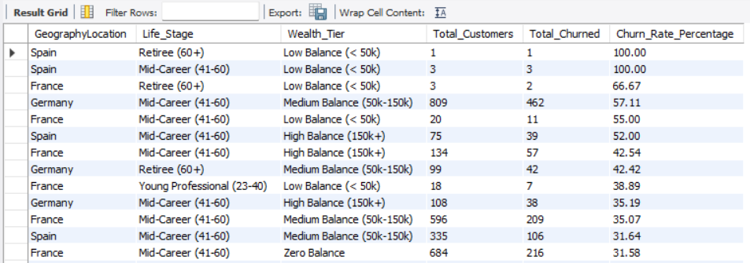
Answer:

- How can we create a conditional formatting setup to visually highlight customers at risk of churn and to evaluate the impact of credit card rewards on customer retention?

Answer:

Part 1: Highlighting "At-Risk" Customers (Conditional Formatting)

To highlight customers, we first need to define what "at risk" means in your dataset. Let's create a DAX measure that flags a customer as high risk if they exhibit standard warning signs (e.g., they are an inactive member and have 1 number of products).

Step 1: Create the Risk Measure (DAX) Go to your Data pane and create this new measure:

Churn Risk Flag =
IF(
MAX('bank_churn'[IsActiveMember]) = 0 && MAX('bank_churn'[NumOfProducts]) = 1,
“High Risk”,
“Low Risk”
)

Step 2: Apply the Conditional Formatting:

- Create a Table visual and add CustomerId, Surname, Balance, and IsActiveMember to the columns.
- In the Visualizations pane, click the down arrow next to CustomerId in the Values well.
- Select Conditional formatting -> Background color.
- In the setup window:
  - Format style: Rules
  - What should we base this on? Select your new Churn Risk Flag measure.
  - Rules: If value is “High Risk”, then set the color to a distinct warning color (like Light Red).
- Click OK.
Your table will now dynamically paint a red background behind any customer who fits the high-risk profile.
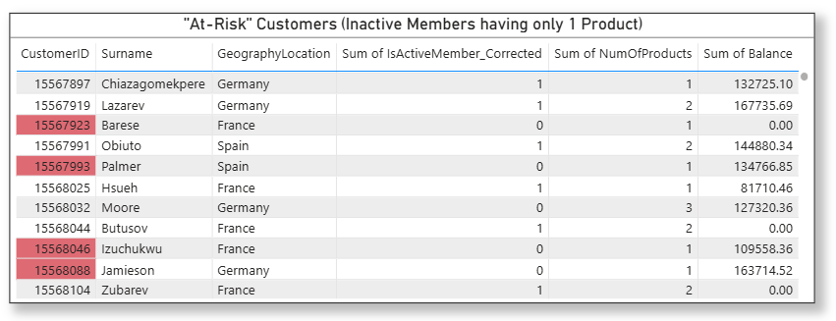

Part 2: Evaluating the Impact of Credit Cards on Retention:

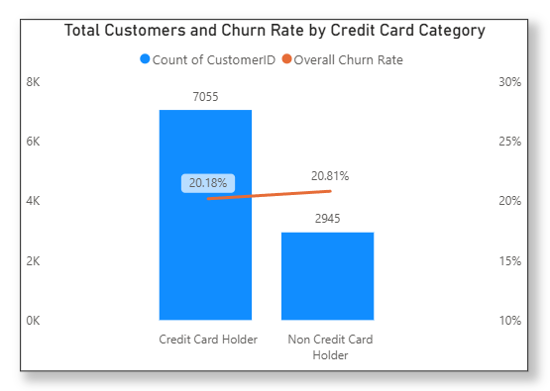
No major impact as both credit card holders and non-credit card holders has the similar churn rate.

- What is the current churn rate per year and overall, as well in the bank? Can you suggest some insights to the bank about which kind of customers are more likely to churn and what different strategies can be used to decrease the churn rate?
Answer:
The overall churn rate stands at 20.37%
In 2016, it was 19.27%, rising to 22.35% in 2017, then decreasing to 20.21% in 2018, and slightly decreasing to 19.86% in 2019.
Customers over the age of 50 and those with fewer products are more prone to leaving. By offering attractive rewards, promotions, and security features to these customer segments, the bank could potentially retain them for a longer duration.

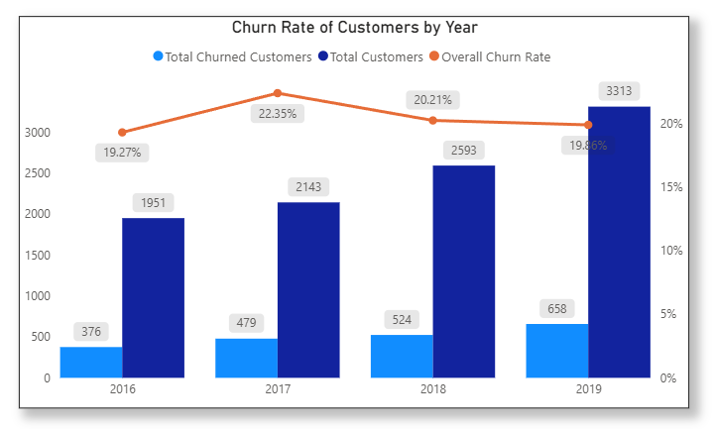
- Create a dashboard incorporating all the KPIs and visualization-related metrics. Use a slicer in order to assist in selection in the dashboard.
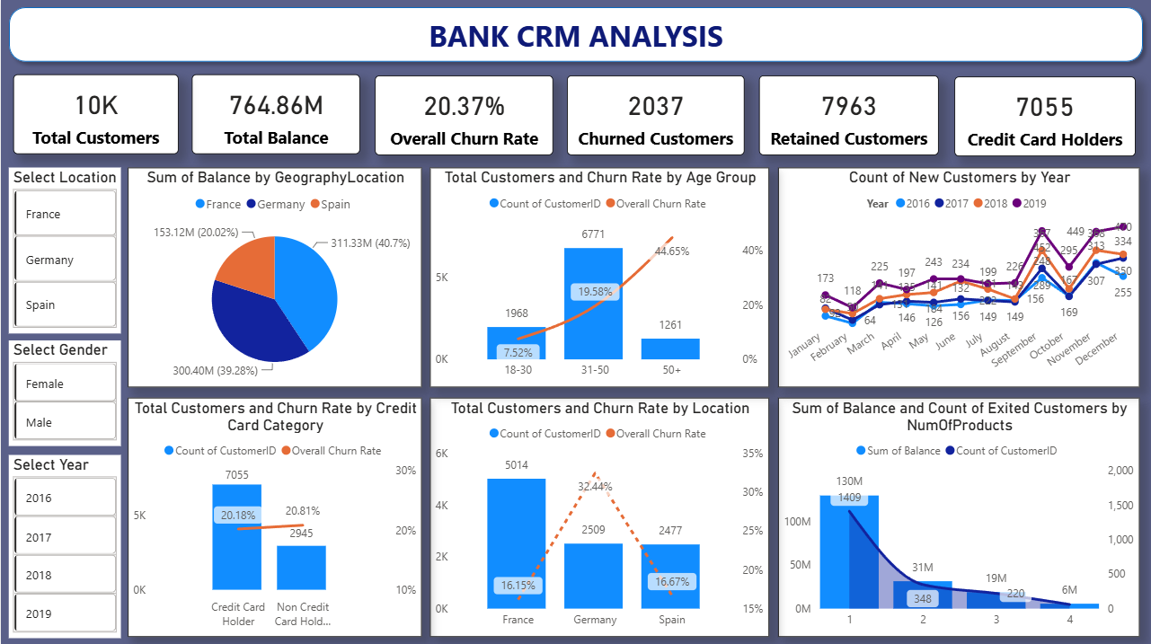
Answer:

- How would you approach this problem, if the objective and subjective questions weren't given?

Answer:
Contextual Understanding: Start by thoroughly comprehending the context and aim of the data analysis. Engage with stakeholders or review project materials to uncover any implicit goals or expectations.

Data Exploration: Perform exploratory data analysis to become familiar with the dataset. Analyse its structure, distributions, and variable relationships, noting any patterns, anomalies, or trends.
Insight Identification: Brainstorm potential insights or hypotheses based on your initial data exploration. Consider both quantitative trends and qualitative factors relevant to the problem domain.

Hypothesis Generation: Develop hypotheses or conjectures from your preliminary observations. Use these as guiding principles for further analysis and testing.

Iterative Analysis Process: Apply a variety of analytical methods iteratively to test and refine your hypotheses. This may involve statistical analysis, machine learning, or qualitative techniques, as well as experimenting with data using tools like Excel, Power BI, and SQL.

Visualization and Communication: Use data visualization techniques to effectively present your findings. Visuals can reveal patterns, relationships, and insights to stakeholders in an understandable way.

Synthesis of Findings: Integrate your findings into coherent narratives or themes, providing a comprehensive understanding of the data. Identify overarching patterns or trends that span different aspects of the analysis.

Feedback and Validation: Validate your results through peer reviews, expert opinions, or external comparisons if feasible. Seek stakeholder feedback to ensure your analysis aligns with their expectations and enhances their understanding of the problem.

- In the “bank_churn” table how can you modify the name of “HasCrCard” column to “Has_CreditCard”?
SQL query:
ALTER TABLE bank_churn
RENAME COLUMN HasCrCard TO Has_CreditCard;

